Final System Design Report

Name

Institution

Date

Final System Design Report
Introduction
Precision Electronic Parts (PEP) is a firm that markets low voltage motors that are mainly for the medical society. Though the company has branched out and has seen an important rise in need for their goods and services. This raise cannot be maintained by the use of the current invoicing and billing system and resulted in processing backlog of a customer invoice, customer payment receipt, and billing. The proposed system Burton’s Business and the IT System Analyst Company (BBISAC) present to the firm allows finance department have more and better control on the invoice development when receiving order, billing and collect payments, the proposal will aid to eliminate late billing and invoicing, and payment collection as also reduce much of processing errors. In its adaptation to its function, a firm must prepare its monthly records, both those that are internal and the external ones. This, therefore, gives the system a core role of receiving information from all the systems and processing it.
Current System
For output requirements, reports of the accounts receivable, reports from monthly invoices and overdue collection reports are collected and analyzed. In receivable accounts, lump-sum payments from customers are selected every 1oth day of every month and processed to make a detailed customer record for the entire month. In monthly reports. The marketing department maintains perfect pricing for the organization's products after an evaluation of the invoicing database every 15th day of the month. In addition, there are overdue collection reports where the invoicing departments' chips in to report sales and accounts receivable department and make sure that it meets the thirty, sixty, and past sixty days criteria. On the other hand, there is the input requirement where the information required is obtained to create a Monthly Invoicing Report. Also, technical requirements are part of the requirements specifications as it describes how to upgrade the application interface with the proposed system. The critical areas needed to look at deals with system control, security, continuity, and performance.
Besides, the technical system is vast in terms of its application, thereby divided into subsections. First, network security, which ensures each workstation connected to the internet or network, has a security protocol connected and isn't exposed to external or internal threats. Secondly, the system user who keeps every user has a single sign-on to protect the credentials f each member and finally maintenance where every system is secured from any attack and regularly tested to ascertain any security measures that may be required in times of difficulties. There is also a control system that ensures that the system functions with respect to how it is intended and that there is data reliability, and the company remains compliant with its regulation and laws (Rouse 2010).
For the company, general controls have to be put on place for fundamental process management, which includes: Risk management, change management, and disaster recovery. Lastly, there is a performance requirement that measures the IT system performance with respect to scalability, workload, and system response time. In a detailed approach, the performance requirements make sure that the system continues to expand and can allow multiple users during peak times. It includes OS, software, and hardware, such as backup and servers’ drives. Also, With the firm's department having different users that are accessing firm databases any time, it is important ensuring the system handles all workload without delays (Lane 2011). For example, simultaneous payment processing from various customers, development of reports from various departments, and also receive data entry from various users.
Furthermore, the system should not have more than 24-hrs to 48hrs between the time the order received and when the record has been entered in the system, the system has to handle multiple users in every department. This brings in the idea of a business continuity strategy where several steps have to put in place for effective and efficient functioning. This starts from creating a business strategy that encompasses continuity, that is, a strategy that ensures on-going business operations with corrective and preventive remediation. This strategy, BBISAC, checks with various departments to receive a list of IT requirements needed. The final process in developing this process is classifying the PEP application on the choice for either technological or operational changes (Williams 2016). Also, there is an implementation of the BC strategy where BBISAC has every information needed; BCP can be executed properly if there raises any need.
Testing has to occur to ensure that BCP necessary changes have been well implemented and result as conveyed. Lastly, there is an on-going maintenance scheme where standard activities procedures of Precision Electronic Parts and left to dust on the self; it has to frequently maintained annually if not at least quarterly. Ensuring a complete execution of business continuity, PEP would add value to the firm through important improvement to be planned. System scope is a crucial risk in terms of upgrading the system; there various negative and positive issues that arise, and when not taken keen would send the project on a tangent, which either has an over-budget or cause project delay. Using a well-labeled diagram to show how the proposed system will function greatly assist in controlling project scope and ensuring the system stays on the path.
Diagram Context.
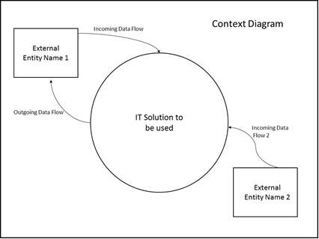

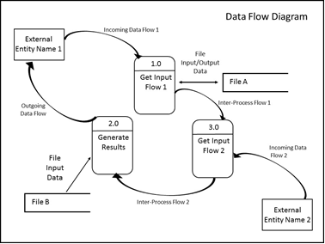
This process model may, therefore, use structured English to describe the system sequence, iterate, and affirm selection criteria. Also, either a decision table or decision tree can be used to represents the information using the knowledge of matrix and graphical data representation, respectively.
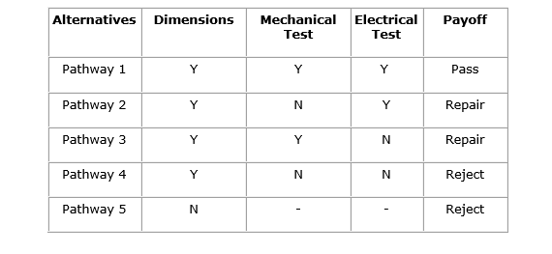

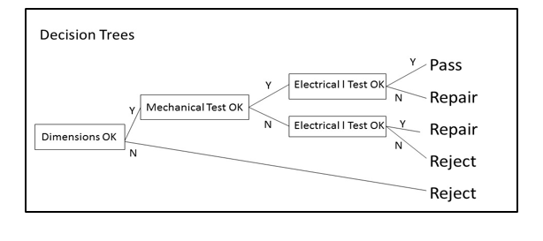
Proposed System
A problem domain within a system design can be rectified into a manageable platform by employing the knowledge of designing. It is through system design that potential problems are solved through the creation of a bridge that instills the solution mechanisms. It is though the reinstallation of a manageable problem domain that the SRS document can be converted to a format whose implementation is simple to regulate in terms of decision making and operation as a whole (Diehl and Christians 2015). To achieve the intended purpose of this system, certain specifications go hand in hand with the main program to satisfy its function. This includes; an infrastructural and organization change for the proposed system. Here the hierarchical structure represents the authority that serves over the accounts, where the end-user of a parent account has authority over the end-user of a sub-account. Every hierarchy will have an Account Administrator who can view financial information and modify certain account characteristics for all the accounts in the hierarchy.

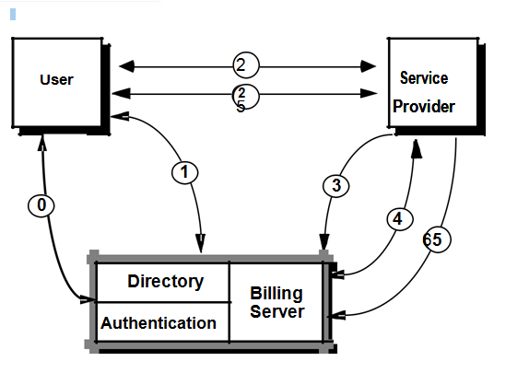
Alternatively, through detailed information and a hierarchical structure, each with a specific node will be used to supply an aggregate of usage information and billing. The organization will now have the ability to give managers privileges to modify some of the information for the accounts of their subordinates. This new hierarchical structure will allow the account environment within the Internet Billing Server to mirror the environment within the organization.
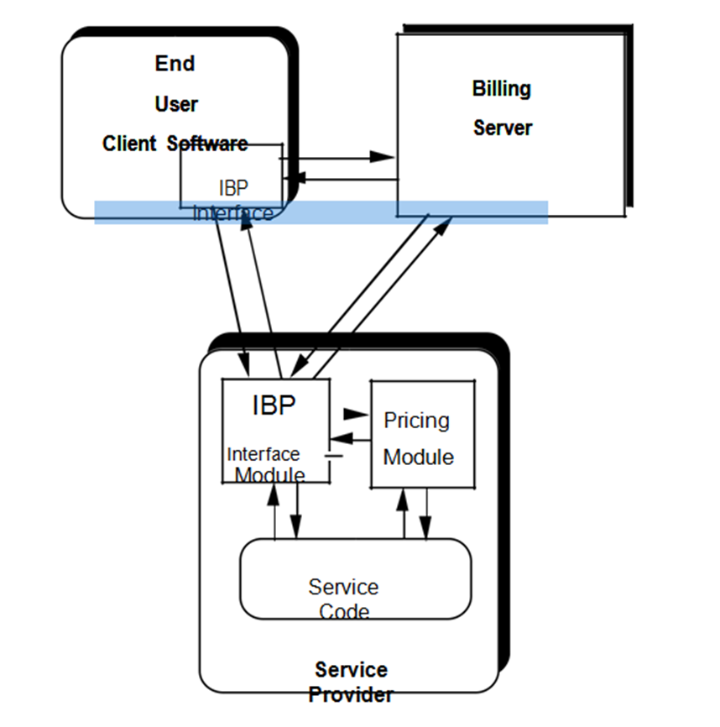
The new system will also have a data schema, which will be a relational schema. It will also contain metadata that will define the tables/files and columns/data-items. A function hierarchy diagram or web page map will graphically describe the program structure. Lastly, there will be an actual code for each module in the program. In its statement of work, the proposed system Burton’s Business and the IT System Analyst Company (BBISAC) will allow the finance department of Precision Electronic Parts (PEP) to have more and better control on the invoice development when receiving order, billing and collect payments, the proposal will aid to eliminate late billing and invoicing, and payment collection as also reduce much of processing errors.
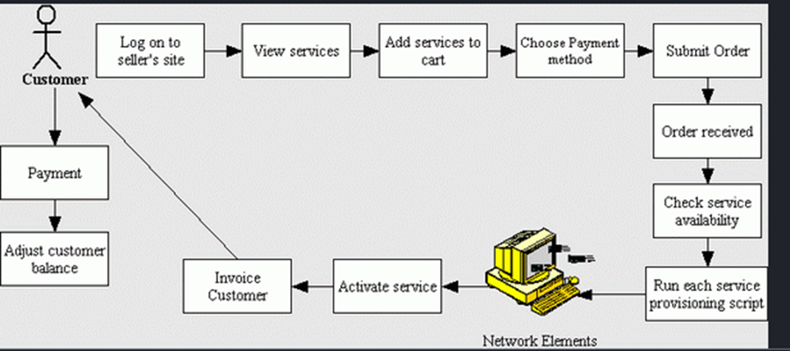
Alternatively, it will include a conceptual data model, modified DFDs, and Metadata (data about data). Before engaging in a network-based transaction, an end-user must first establish an account with the Internet Billing Server (Diehl & Christians 2015). In our design, any number of accounts may be organized in a hierarchical fashion by allowing each account to have sub-accounts, each of which is also an account.

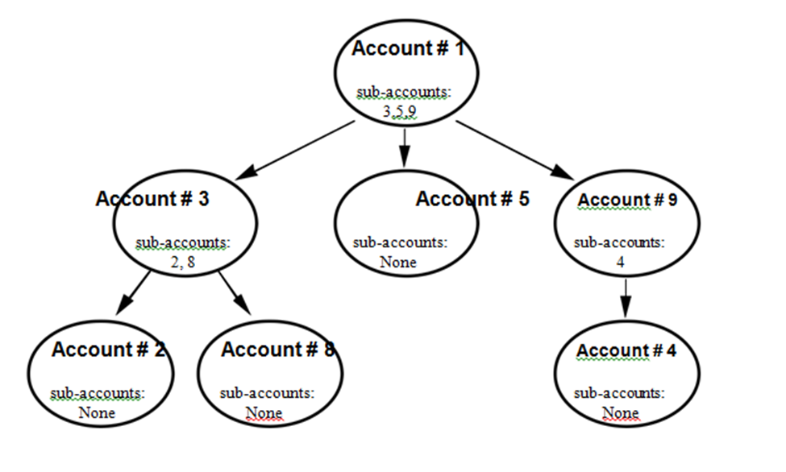

Its physical design relates to the actual input and output process, where it focuses on how data is entered into the new system, verified, processed, and displayed as output. This is effectuated through the definition of design specification by the system, where it directly deals with the process, interface, and data designs. Architectural design is known as a high-level design that focuses on the design of system architecture. It describes the structure and behavior of the system. It defines the structure and relationship between various modules of the system development process. Conceptual data modeling captures the meaning of the data collected using the E-R model. Also, there is the entity-relationship model that uses the database design to describe the relationship between various entities of an organization. This design gives a detailed order upon which records will be stored within a file, that is, serial, sequential, direct, or indexed.
Cost is the disbursement that has to be catered for irrespective of what the firm is making a profit as long as its operation is beyond bankruptcy. Therefore, cost plays the most influential role in determining the quality of the end product. Current trend analysis shows that more firms are moving from manufacture and distribution and instead of venturing in solution provision, which approximates to $350m as a minimum initial operation cost. Also, based on the Association for the Advancement of Cost Engineering, it is approximated that production cost has a greater impact on the overall sale of the product services being provided. This system, therefore, has a variety of positive impacts in its operation as opposed to the previous system. First, it will reduce system downtime, cut costs, and speed up maintenance tasks. Secondly, it will provide a clear description of the formal flow of the present system and help to understand the type of input data and how the output can be produced. Finally, it will provide an effective and efficient way of communication between technical and nontechnical users about the system.
Summary
The precision Electronic Parts entirely deals with motor-related medical products. This has increased their popularity over time, demanding a better financial operation for the firm to avoid cases of misappropriates in terms of internal and external cash flow. In the past, invoicing and billing -was the quick method to address financial concerns, but the increasing population demands a better technique to help cater to all the stakeholders at a reasonable pace and avoid delays too. It is from this that the new system design has been put in place to help ease the menace that was already crouching up the production sector. This new design segregates the operational area practices in several departments, each with a specific mode of running. For instance, input, output, and technical system designs. Also linked to this are detailed documentation and record-keeping platforms that make traceability of the firm's operations easy.

In conclusion, the System analyst role is responsible for analyzing a business's entire collection of computer and IT network systems. Due to this, its purpose as an operational mechanism can be termed as an IT role overall. This is because if it were a business role, it would be more pertaining to analyzing the business rather than its IT aspects. Therefore, a job specification as a system analyst has a greater opportunity in helping one learn more practical work as a complement to theoretical classwork.

References
Awad, M., & Khanna, R. (2015). Efficient learning machines: theories, concepts, and applications for engineers and system designers. Apress.
Diehl, J. C., & Christians, H. H. C. M. (2015). Product service system: The future for designers. In Proceedings of the International Design Conference of KSDS and ADADA with CUMULUS (pp. 17-18).
Lane, D. (2011). The chief information officer's body of knowledge: people, process, and technology. [Books24x7 version] Retrieved from http://common.books24x7.com. ezproxy.umuc.edu/toc.aspx?bookid=44315.
Rouse, M. (2010). IT Controls. TechTarget. Retrieved on September 12, 2019, from http://searchcompliance.techtarget.com/definition/IT-controls
Williams, T. (2016). EMC for product

